**DAILY ONLINE ACTIVITIES SUMMARY**

|  |  |  |  |  |  |  |  |  |
| --- | --- | --- | --- | --- | --- | --- | --- | --- |
| **Date:** | **19/6/2020** | | | | | **Name:** | **Apoorva U** | |
| **Sem & Sec** | **8th Sem** | | | | | **USN:** | **4AL16CS017** | |
| **Online Test Summary** | | | | | | | | |
| **Subject** | | **BDA** | | | | | | |
| **Max. Marks** | | **30** | | **Score** | | | **26** | |
| **Certification Course Summary** | | | | | | | | |
| **Course** | **Introduction to SQL** | | | | | | | |
| **Certificate Provider** | | | **Datacamp** | | **Duration** | | | **4hrs** |
| **Coding Challenges** | | | | | | | | |
| **Problem Statement:**  Python Function to rotate the matrix 90 degree clockwise. | | | | | | | | |
| **Status:COMPLETED** | | | | | | | | |
| **Uploaded the report in Github** | | | | | **yes** | | | |
| **If yes Repository name** | | | | | **Apoorva_u** | | | |
| **Uploaded the report in slack** | | | | | **yes** | | | |

Online Test Details: (Attach the snapshot and briefly write the report for the same)

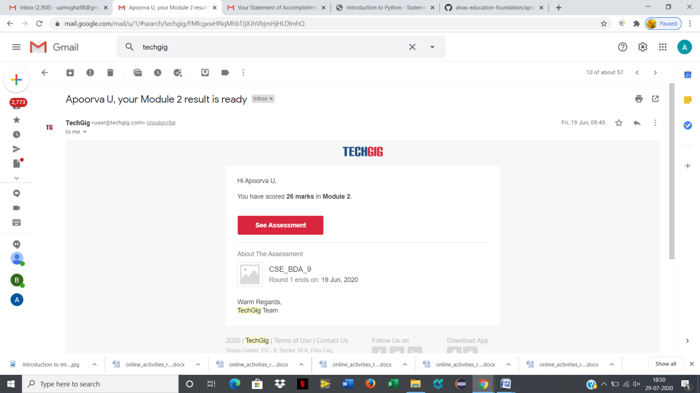

Certification Course Details: (Attach the snapshot and briefly write the report for the same)

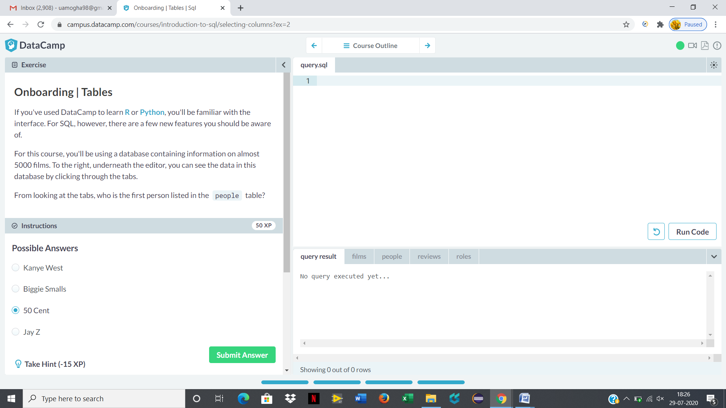

Coding Challenges Details: (Attach the snapshot and briefly write the report for the same)

Python Function to rotate the matrix 90 degree clockwise.

def rotate90Clockwise(A):

N=len(A[0])

for i in range(N//2):

for j in range(i,N-i-1):

temp=A[i][j]

A[i][j]=A[N-1-j][i]

A[N-1-j][i]=A[N-1-i][N-1-j]

A[N-1-i][N-1-j]=A[j][N-1-i]

A[j][N-1-i]=temp

def printMatrix(A):

N=len(A[0])

for i in range(N):

print(A[i])

A=[[1,2,3,4],[5,6,7,8],[9,10,11,12],[13,14,15,16]]

rotate90Clockwise(A)

printMatrix(A)